**LAPORAN PRAKTIKUM**

**PEMROGRAMAN TERSTRUKTUR**

**MODUL 7 FOR-TO-DO BERGANDA**



**Dikerjakan oleh:**

**Nama: Erick Erdiansyah**

**Kelas: TI A**

**NIM: 3202216014**

**Program Studi Teknik Informatika Jurusan Teknik Elektro**

**Politeknik Negeri Pontianak**

**Pontianak**

**2022**

**MODUL VII**

**PERULANGAN**

**DENGAN FOR ... TO ... DO ... BERGANDA**

* + 1. **TUJUAN**

1. Memahami prroses perulangan berganda dengan jumlah yang diketahui
2. Mampu mengaplikasikan proses perulangan berganda dalam Pascal
3. Mampu mengimplementasikan kasus ke dalam bentuk program Pascal
   * 1. **DASAR TEORI**

Bentuk umum dari FOR ... TO ... DO ... berganda adalah sebagai berikut :

FOR var_penghitung1 := nilai_awal1 TO nilai_akhir1 DO

FOR var_penghitung2 := nilai_awal2 TO nilai_ahir2 DO

BEGIN

Statement1;

Statement2

...

END;

Pada perulangan berganda, dibutuhkan minimal 2 buah variabel penghitung, tergantung jumlah FOR ... TO ... DO ... dalam program tersebut. Nilai awal dan nilai akhir pada masing-masing perulangan bisa sama.

Kasus yang biasa diselesaikan dengan perulangan berganda adalah persoalan matriks.

* + 1. **LATIHAN SOAL**

1. **Nomor Program 0701**
   1. Tulislah program berikut dan amatilah outputnya!

PROGRAM deret_bintang;

USES CRT;

VAR karakter : char;

baris, i, j, kolom : integer;

BEGIN

CLRSCR;

FOR i := 1 TO 5 DO

BEGIN

FOR j := 1 TO 20 DO

BEGIN

TEXTCOLOR(i);

WRITE(‘*’);

END;

WRITELN;

END;

READLN;

END.

* 1. Ubahlah nilai variabel penghitung i, mulai 1 s.d. 20. Kemudian ubah juga nilai variabel penghitung j, mulai 1 s.d. 5. Bagaimana outputnya, apa kesimpulan anda?

Jawab : Perulangan i dilakukan terlebih dahulu kemudian baru j, dan i tidak menambah apa-apa selain mengulang j.

..................................................................................................................

..................................................................................................................

..................................................................................................................

1. **Nomor Program 0702**

Buatlah program untuk menampilkan output seperti berikut :

1234567890

1234567890

1234567890

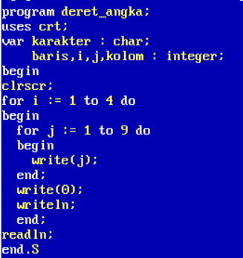

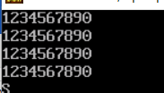

........................................................................................................................

........................................................................................................................

........................................................................................................................

........................................................................................................................

........................................................................................................................

1. **Nomor Program 0703**

Buatlah program untuk menampilkan output seperti berikut :

1111111111

1111111111

1111111111

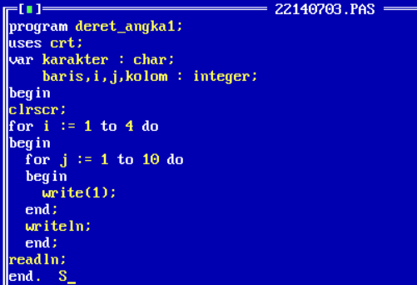

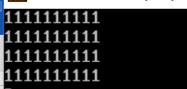

........................................................................................................................

........................................................................................................................

1. **Nomor Program 0704**

Buatlah program untuk menampilkan output seperti berikut :

*

* *

* * *

* * * *

* * * * *

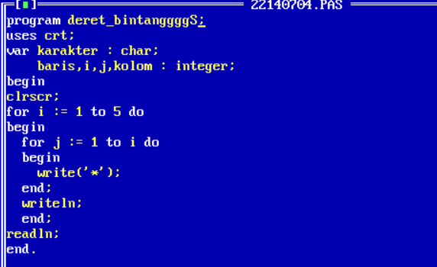

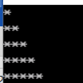........................................................................................................................

........................................................................................................................

........................................................................................................................

........................................................................................................................

1. **Nomor Program 0705**

Buatlah program untuk menampilkan output seperti berikut :

1

1 2

1 2 3

1 2 3 4

1 2 3 4 5

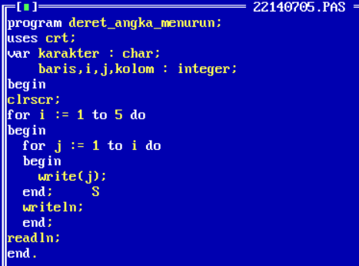

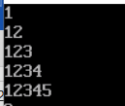

........................................................................................................................

........................................................................................................................

1. **nomor Program 0706**

Buatlah program untuk menampilkan output seperti berikut :

1 = 1

1 2 = 3

1 2 3 = 6

1 2 3 4 = 10

1 2 3 4 5 = 15





















